DOCKER CLASS - 1
Launch an EC2 Instance

Go to Amazon Web Services Console.
Open Amazon EC2.
Click Launch Instance.
Choose:

OS: Amazon Linux or Ubuntu
Instance type: t2.micro (free tier).
Create / select Key Pair.
Allow SSH (port 22) in security group.
Launch the instance.
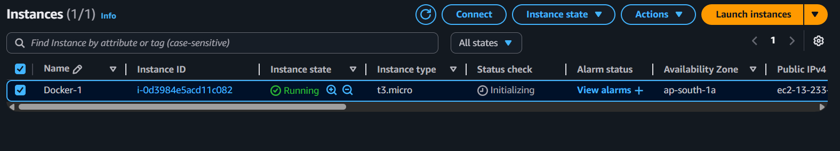
Update the System
Update packages before installing Docker.
For Amazon Linux:
sudo yum update -y
For Ubuntu:
sudo apt update

Install Docker
Amazon Linux
sudo yum install docker -y
Ubuntu
sudo apt install docker.io -y
Start Docker Service
sudo systemctl start docker
Enable Docker to start automatically.
sudo systemctl enable docker

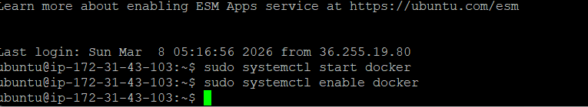
Verify Docker Installation
docker --version

Example output:
Docker version 24.x.x
Test Docker using hello-world.
sudo docker run hello-world
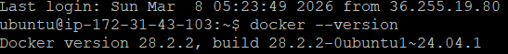
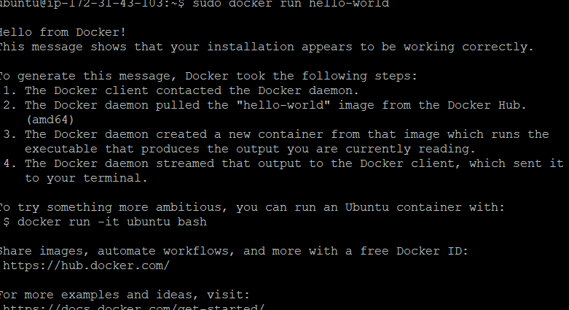
Run Docker Without sudo (Optional)
Add your user to docker group.
sudo usermod -aG docker $USER
Then logout and login again.
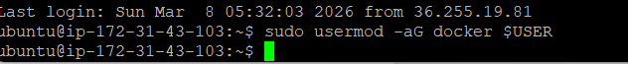
Explore Docker Images
List Images
docker images
Pull an Image
Example: Pull nginx image.
docker pull nginx
Remove Image
docker rmi nginx
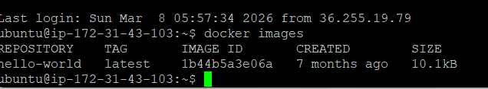
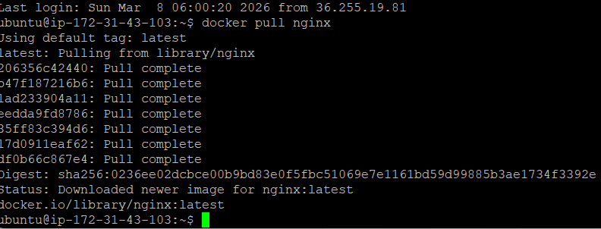
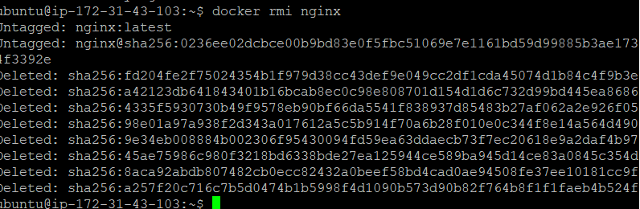
Explore Docker Containers
Run a Container
docker run -d -p 80:80 nginx
Explanation:

-d → run in background

-p → port mapping

List Running Containers
docker ps
List All Containers
docker ps -a
Stop Container
docker stop <container_id>
Remove Container
docker rm <container_id>
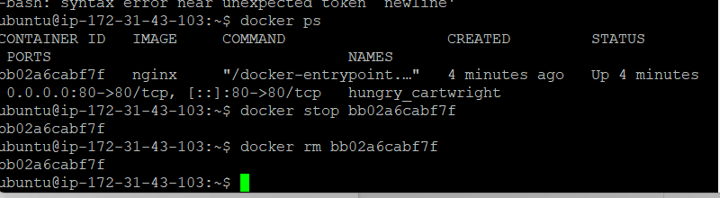
🔟 Explore Docker Volumes
Volumes store persistent data.
Create Volume
docker volume create myvolume
List Volumes
docker volume ls
Inspect Volume
docker volume inspect myvolume
Remove Volume
docker volume rm myvolume
Explore Docker Networks
List Networks
docker network ls
Default networks include:

bridge
host
None
Create Network
docker network create mynetwork
Inspect Network
docker network inspect mynetwork
Remove Network
docker network rm mynetwork
Useful Docker Commands Summary
Command | Purpose
docker images | list images
docker pull image | download image
docker run | start container
docker ps | running containers
docker stop | stop container
docker rm | remove container
docker volume ls | list volumes
docker network ls | list networks

